CSE-326

Project Title: Grocery Website

Submitted To: Sukhvir Kaur mam

Submitted By: Saksham Kapil[11902599]

Vijay Reddy[11902545]

Mannam Tarun[11902906]

Section:KI9SJ(group 1)

INTRODUCTION

"Smartkart" is a web site. This system is developed to automate day to day activity of a grocery store. Grocery is a kind of business that serves people all over world . This system is developed to provide service facility to the customer. This system can be used by employees in a store to handle the clients, their orders and can help them easily place orders. The services that are provided is grocery ordering by the customer through the system online, customer information management. The products menu is organized by categories (fresh source, grocery, dairy products) of menu items. Main objective build the system this is to provide ordering or buying the products online by the customer. Each menu item has a name, price and associated description. With this system online, ordering will become easier and systematic to replace traditional system where are still using paper. To order a product online, the customer has to become a member first. this project to facilitate customer for make online ordering . The option of becoming member was only an attempt to avoid (to some extent) placing the fake orders.  
  
Smartkart is the system for manage the grocery business. After successful login the customer can access the products page with the items listed according to the desired requirement. The main point of developing this system is to help store administrator manage the grocery business and help customer for online ordering and buying. In proposed system user can search for a menu according to his choice i.e. category of products and later he can order a product.  
  
The project is developing because; many stores have a lot difficult to manage the business such as customer ordering . If the customer book an order and later wants to cancel the order, he is permitted to do this only within a specific time period. By using manual customer ordering is difficult to delivery boy keep the correct customer information and maybe loss the customer information. The customer is also given with the facility to view the status of the order and if the order is ready then he can go and get it.  
  
So, Smartkart will develop to help the store administrator to manage store management and for customer make their online ordering. Other than that, this project is to upgrade the manual system and make the business easily to access and systematic.

FLOW CHART OF WEBSITE

Customer

feedback

Order

confirmation

Shopping

item

User

login

Since 2000

S

Main

Page

page

Grocery Products

Grocery Store Store

About team

and store tour

Create account

DESCRIPTION

1.HOME PAGE-In this page connections to other pages are made using links .As in this homepage buttons like HOME,REVOLUTION,PRODUCTS,ADVANTAGES,ABOUTUS,SIGNUP,LOGIN,CART, CHECKOUT and FEEDBACK are linked to the respective pages providing particular information related to the pressed link.

In HTML we use css in head section to style the website. There are three types of css Inline, Internal, External “CSS. In this project we have used internal and external“CSS” to style our website.

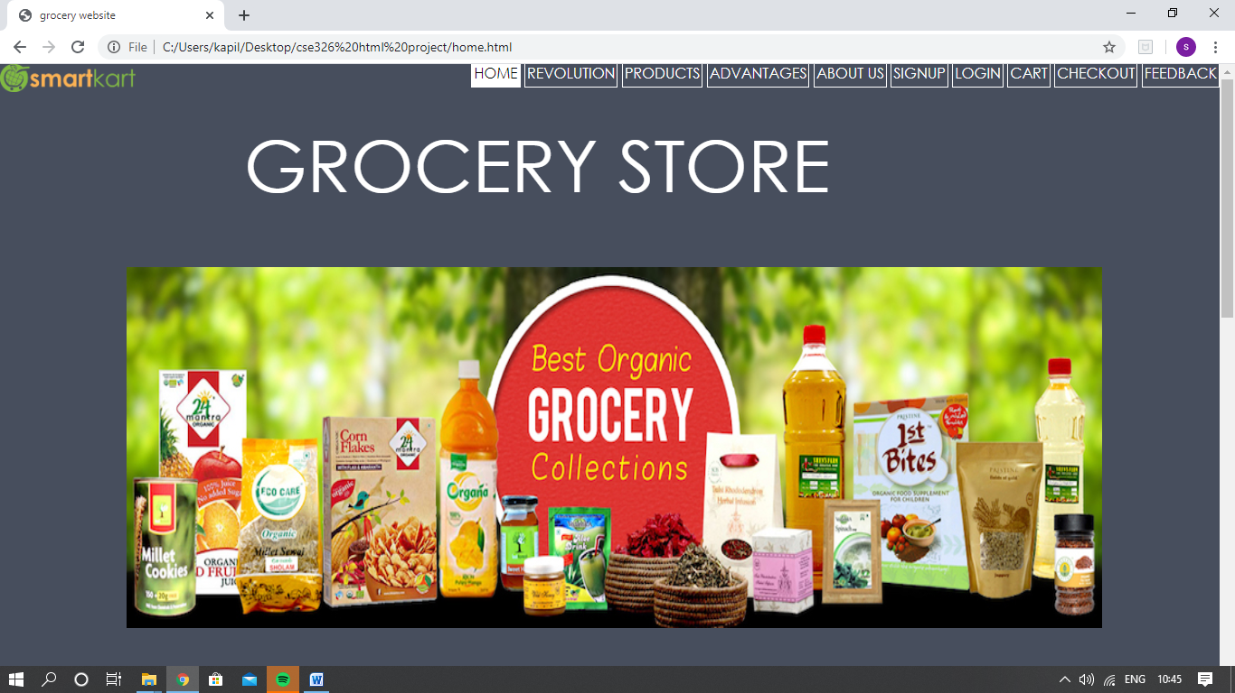

2.Revolution

In this page revolution of store is given.

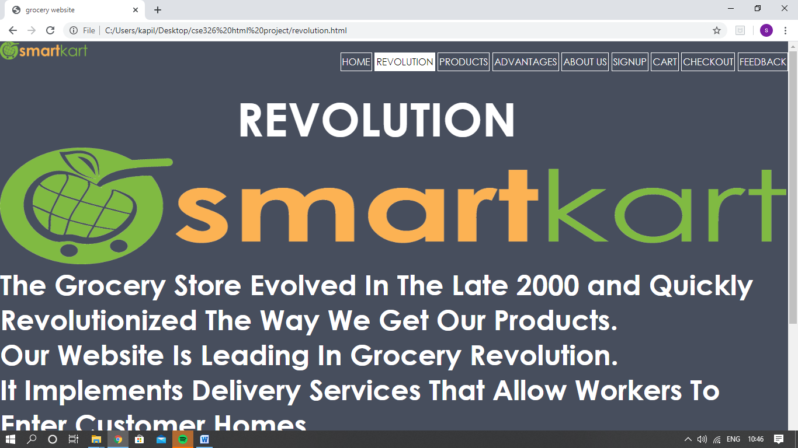

3.PRODUCTS PAGE:

This page gives the detailed information about many type of products available to the customer .In this page we used html, css and javascript .

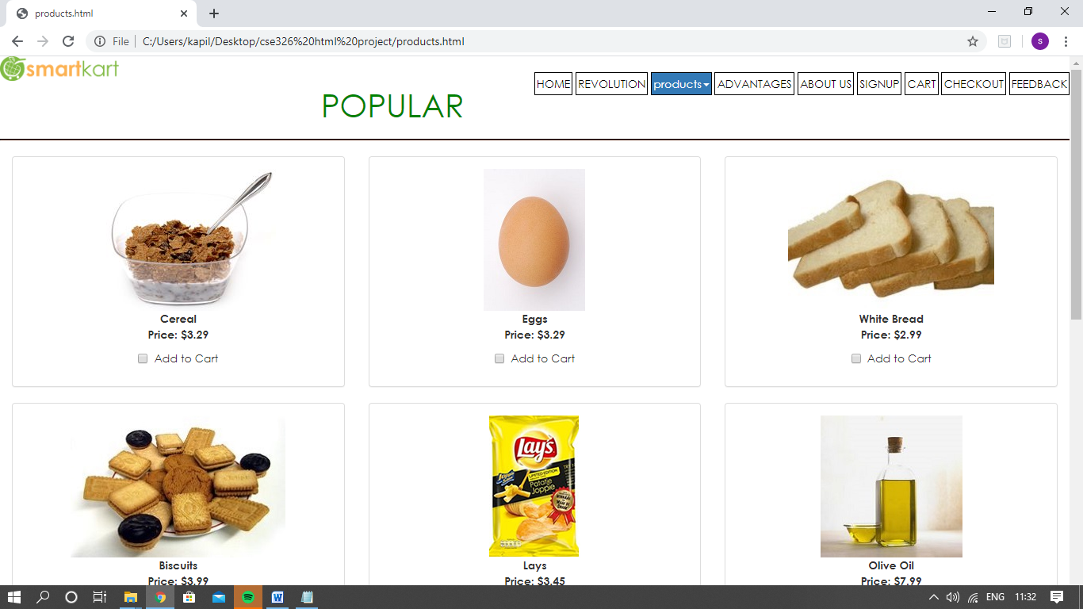

4.ADVANTAGES

In this page we have details about WHY SMARTKART GROCERY.

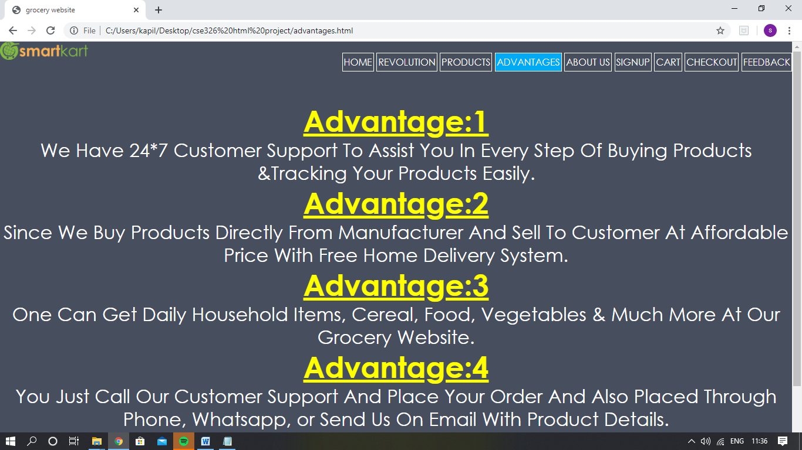

5.ABOUT US

In this page we have details about our team and store tour and its motives. To have a look on the pictures of store for the customer who visit the website

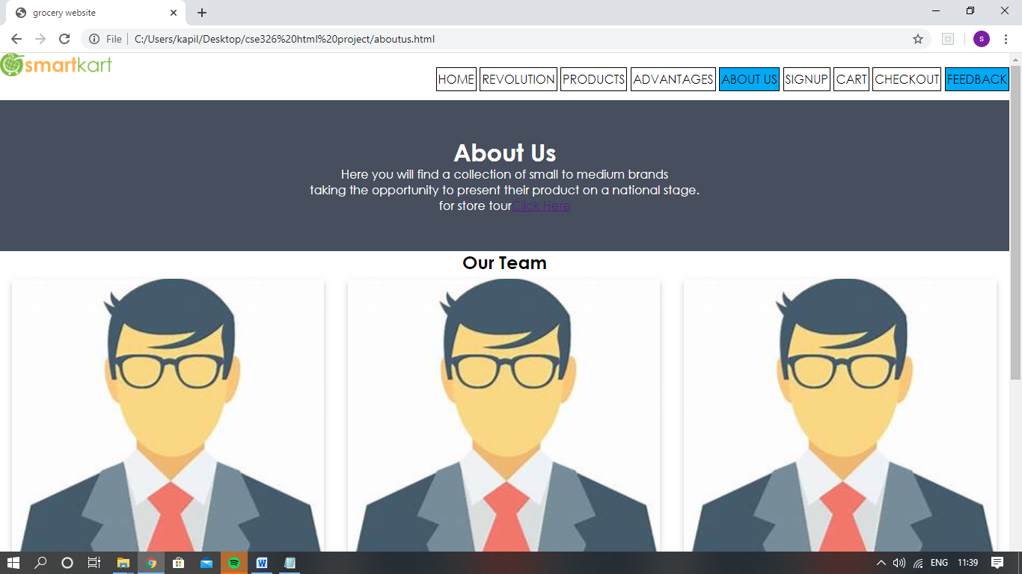

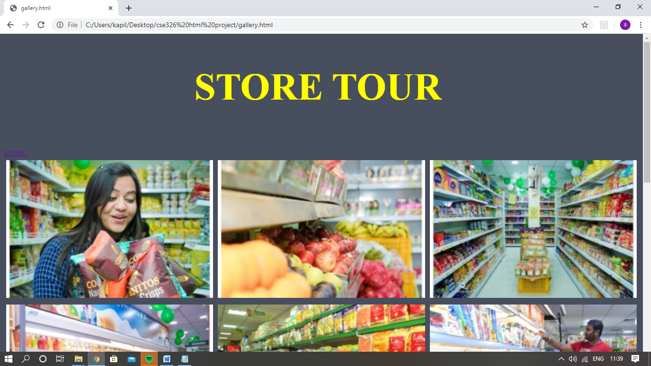

6,7.SIGNUP AND LOGIN PAGE:

This section of webpage we SIGNUP OR SIGNIN of the customer who visit the website .

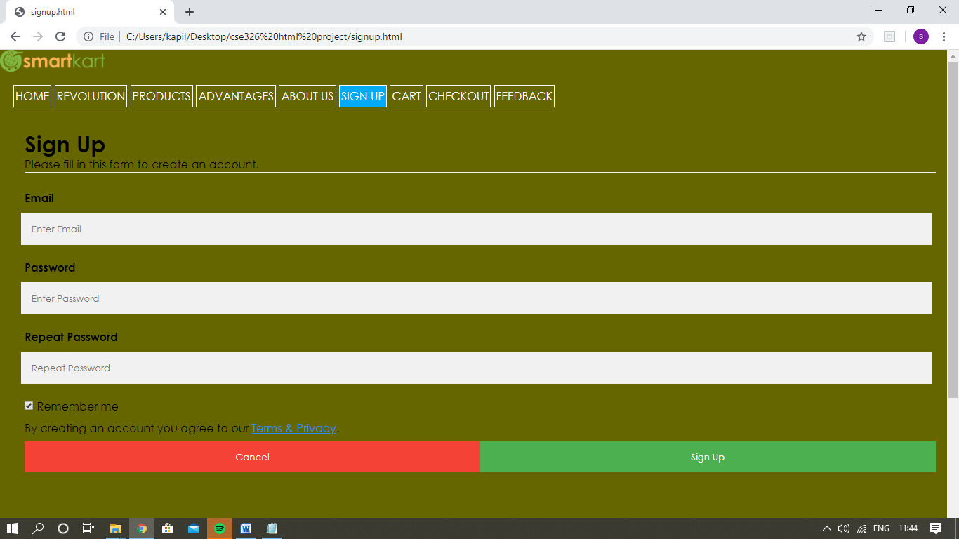

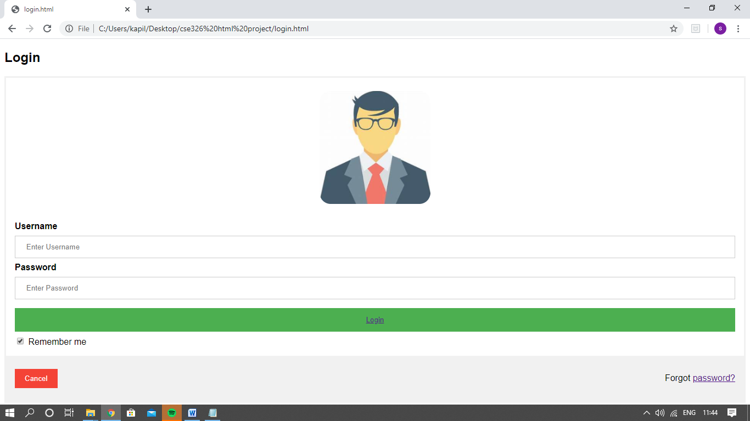

8,9:CART,CHECKOUT

This page add items to cart and checkout page leads gateway to payment.

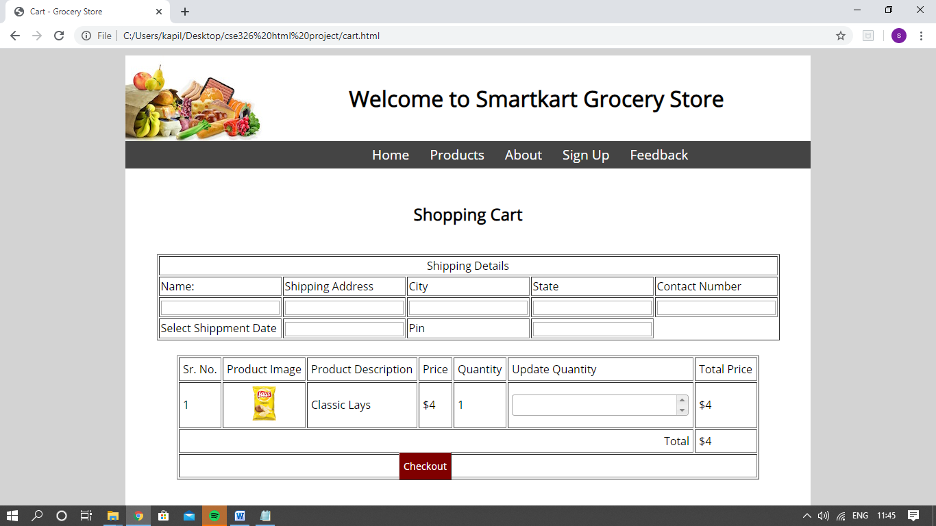

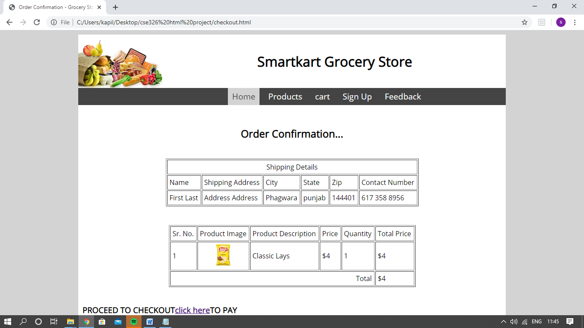

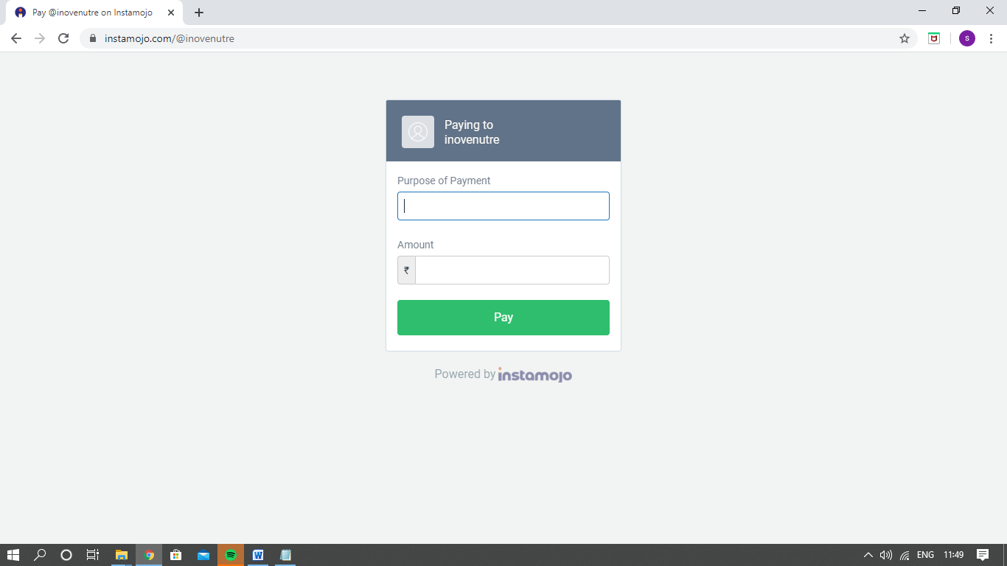

10.FEEDBACK:

This page takes feedback from the customer about service

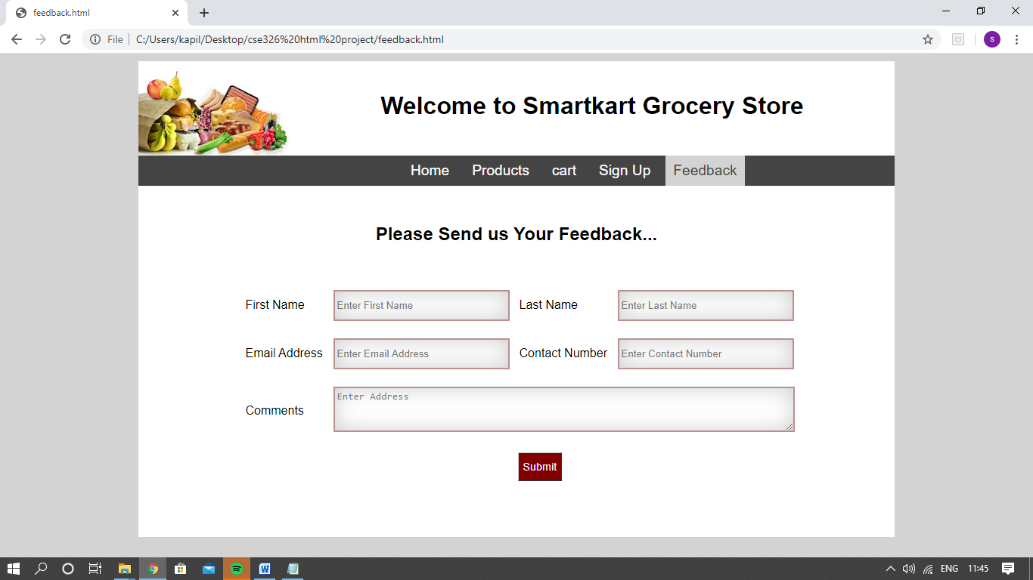

MODULE

1.Homepage:

The home page is done by Saksham. This section is done by using HTML and CSS.

2.Revolution:

This page is done by Saksham , this page explains about the revolution of store. This is done by using HTML and CSS.

3.Products:

This page is done by Saksham, this page has the product listby in the store. This is done by using HTML CSS and javascript.

4.Advantages:

This page is done by Saksham, this page have tells why us. This is done by using HTML and CSS.

5.About us:

This page is done by Saksham, this page explains about does and donts while eating food. This is done by using HTML and CSS.

6.Signup:

this page create account of customer. This is done by Vijay. This is done by using HTML, CSS and javascript.

7.Login:

this page login the customer. This is done by Tarun. This is done by using HTML, CSS and javascript.

8,9,10.Cart,Checkout,and Feedback:

Cart and checkout page to finish the shopping. This is done by Saksham.This is done by using HTML, CSS and javascript.

While feedback page is used to take customers feedback. This is done by Saksham.This is done by using HTML, CSS and javascript.

Video of working website: <https://youtu.be/gXXtgsdepPA>

WEBSITE IMAGE



CONCLUSION:

This project is based on a webpage designing is really knowledgeable project. HTML has been used in this project to create a website based on grocery. We have learned how to create structured and functional HTML documents-everything builts on this.To conclude with this project helps in advertising a store by creating a grocery website using HTML.Under which various types of tags are used to make the website attractive and eyecatchy while displaying all the important information about grocery store .